Homework 3

1.

a)

* One slide 3, how does the writer encourage the reader “to see the world”?
  + He encourages us to see the real world as a database schema
* What is der_order_price on slide 6?
  + Derived field showing the total price
* On slide 7, he identifies a benefit of storing addresses in a separate table. What is it?
  + It is a distinguishing characteristic between a database schema with limited scope, and one for use in a mission-critical capacity
  + Allow to validate the address against files of recognized addresses
  + Helps track changes in customer addresses

b)

* How would you modify it so that a customer could have more than one address?
  + Add an intermediate table for addresses like amazon

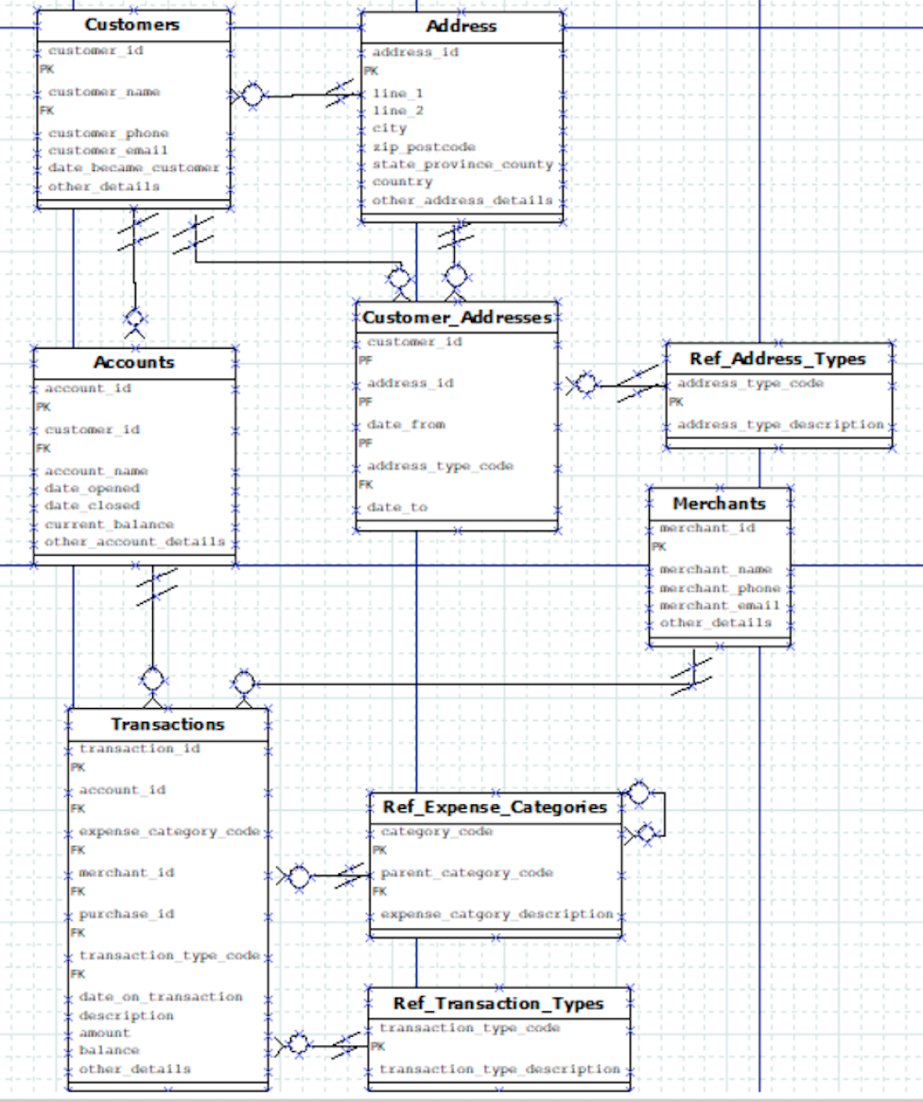

2.

a)

* Write a CREATE TABLE statement for table Valid_Answers.
  + CREATE TABLE Valid_Answers(Valid_Answer_ID INTEGER PRIMARY KEY, Question_ID INTEGER, Valid_Answer_Text VARCHAR(255));
* A professor uses an application to prepare an exam. What database tables would an application SELECT from to help a professor ‘look at’ a previous exam?
  + Look at the exams table, join that with the Questions_in_Exams table, and join that with the Questions table. This way he can look up past exams, and see what questions were on them.
* A student uses an application to take an exam. What tables would the application query to administer an exam?
  + All of them (assuming the test program auto grades the questions as they are answered). If test is not autograded, all tables would be used except for Valid_Answers table
* As a student worked thru the exam, what tables would be modified by inserting or updating records?
  + Student_Answers and Student_Assessments

3.

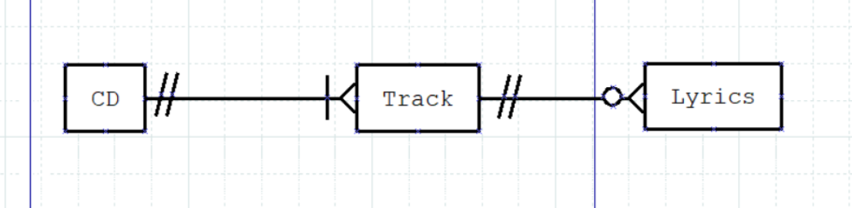

4.

Preliminary Class Diagram

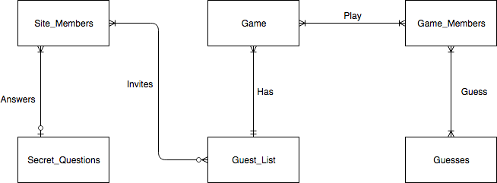

ERD

